Quiz for Clean Kerala:A Statewide Water Quality & Sanitation Challenge
For Higher Secondary Students
(+1, +2 of Kerala Syllabus , CBSE, ICSE)
Preamble
Water quality and sanitation are among the most pressing concerns of our time. With the increasing incidence of water contamination and related issues, especially in regions like Kerala where traditional water sources such as wells and borewells are widely used, there is a growing need for awareness and education on these topics.
This programme is designed with the objective of creating awareness among the student community about the importance of water quality and sanitation. Recognizing the role of youth in driving sustainable change, the initiative seeks to equip students with the knowledge and tools necessary to understand and address water-related challenges in their surroundings. We are also prepared to provide study materials and facilitate interactive sessions for students who are interested in taking up assignments or projects related to water quality and sanitation. This awareness programme is a collaborative effort jointly organized by the Centre for Water Research and Education (CWRE), Unnat Bharath Abhiyan (UBA), and the Indian Society for Technical Education (ISTE).
The CWRE, functioning under the Department of Civil Engineering at Jyothi Engineering College, is actively engaged in research, education, and outreach activities focused on water and sanitation. Our core mission includes Information, Education, and Communication (IEC) in the water sector, aimed at empowering communities to address water-related challenges. We operate a government-approved commercial water testing laboratory and offer water testing services at a nominal fee. In addition, CWRE conducts training programmes, publishes books and articles, and undertakes various community-oriented initiatives related to water conservation, quality monitoring, and sanitation awareness. We hope that this initiative will inspire students to become proactive contributors in promoting safe water practices and sustainable sanitation solutions in their communities.

Modality and Eligibility for the Water Quality & Sanitation Awareness Examination
- Eligibility Criteria:
  - Students currently studying in Plus One (+1) and Plus Two (+2) under the Kerala State Syllabus, CBSE, or ICSE are eligible to participate.
  - Only students from Kerala state are permitted to appear for the examination.
  - Participants must be currently enrolled in school and must produce a valid identity proof at the time of the examination.

Examination Details:
  - The exam will be conducted in offline mode at Jyothi Engineering College. Students are required to make their own travel arrangements.
  - The question paper will consist of 100 multiple choice questions (MCQs).
    - Out of these, certain questions will be starred and used as tie-breakers if needed.
    - 60 sample questions are provided in advance, and 50 of these will appear in the final exam.

  - The exam key will be published within 5 hours of completion of the examination.
  - A formal challenge window will be provided for students to contest the answer key, within a specified time frame.

Registration and Fee:
  - An entrance fee of ₹100 will be charged per candidate.

Awards and Prizes:
  - Attractive cash prizes will be awarded to the top performers:
    - First Prize: ₹10,000
    - Second Prize: ₹7,000
    - Third Prize: ₹5,000
  - All prize winners will also receive Certificates of Merit.
  - Those who score 50% or above will receive Consolation Certificate

Additional Information:
  - Students may contact the Centre for Water Research and Education (CWRE) for any clarification or assistance.
  - In case of any disputes, the decision of the Administrative Committee will be final.
  - Further details will be made available through the official CWRE website
  - [cwre.jecc.ac.in](http://cwre.jecc.ac.in)
  - Tentative date for the written exam is 1st November .2025

Office bearers for the programme are as follows:

Sl.No | Name and Designation | Phone number
1 | Fr. David Nettikkaden , Executive Manager
2 | Dr. P Sojanlal, Principal
3 | Dr. Alwyn Varghese, HOD CE
4 | Prof. Cyriac.M.G, General Convener | 9447732619
5 | Ms. Anna Joseph, Convener | 9400947041
6 | Mr. Suhas Nair S, Convener | 6381153948
7 | Ms. Jeffy Johny, Convener | 7025168862
8 | Mr. Alfred George, Convener | 9995890881
(NB: The faculties mentioned in4,5,6,7,8 may be contacted for any clarifications)

Syllabus

Topic: Water Quality and Sanitation Awareness
This syllabus is designed to provide students with a fundamental understanding of water quality, sanitation, and related public health and environmental concerns. The content is aimed at creating awareness and promoting informed action among young learners.

Water Quality and Sanitation: An Overview
  - Global scenario of water quality and sanitation

  - Relevance of water quality in daily life and health

Water Quality Parameters
  - Physical Parameters:
    - pH
    - Turbidity
    - Conductivity
    - Total Dissolved Solids (TDS)
  - Chemical Parameters
    - Chloride
    - Alkalinity
    - Hardness
    - Nitrate
    - Sulphate
    - Chemical Oxygen Demand (COD)
    - Biochemical Oxygen Demand (BOD)
  - Biological Parameters:
    - Coliform bacteria
    - E. coli contamination

Contamination and Pollution
  - Heavy metal contamination in water
  - Pesticide pollution and its effects
  - Sources and effects of contamination

Waterborne and Water-based Diseases
  - Common diseases:
    - Cholera
    - Typhoid
    - Leptospirosis
    - Other bacterial and viral infections

Water Quality Issues in Kerala
  - Local challenges in water quality
  - Community-based and technological remedies

Water Treatment Methods
  - Filtration
  - Disinfection and Chlorination
  - Use of water treatment kits and basic household practices

Sanitation and Waste Management
  - Household Sanitation Systems:
    - Septic tank
    - Leach pit
    - Soak pit
  - Solid Waste Management at Household Level

  - Role of Local Self Government Departments (LSGD) in managing solid and liquid waste
  - Personal and environmental hygiene
  - Maintenance of home and surroundings
  - Importance of regular hand washing

National and Global Initiatives
  - Swachh Bharat Abhiyan (Clean India Mission)
  - Sustainable Development Goals (SDGs) on water and sanitation
This syllabus form the basis for the multiple-choice questions (MCQs) in the examination. Students are encouraged to explore each topic for both theoretical understanding and practical relevance.
For any clarification or study support, students may contact the Centre for Water Research and Education (CWRE).

Questions for the exam

Out of the 60 questions given below 50 will appear in the final exam , another 50 % will be added separately

1.0 What does the below picture indicate
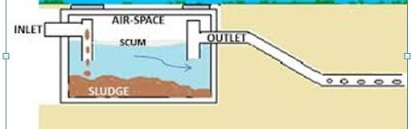sssssss
a)leach pit b) septic tank c)Soak pit d)none
2.0 What does the below picture indicate
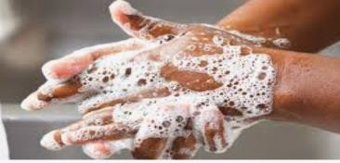
a)Hand washing is important for hygiene b) Hand washing prevents from diseases
c) children are more vulnerable for related diseases d) all of above
3.0 What does the below picture warn
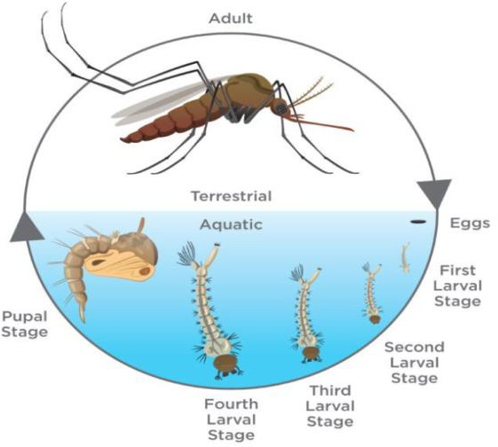
a)Mosquito growth is dangerous for human life b) always cautious about mosquito growth c)stagnated water should be avoided around the premises d) all of the above
4.0 Which statement is appropriate for the given picture

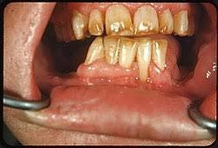
a. Blue baby syndrome b)keratosis c) fluorosis d) none
- What does the picture below indicate
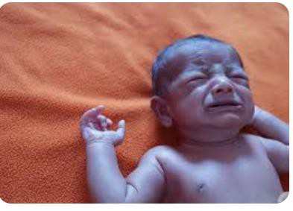
  - Fluorosis b)keratosis c) Blue baby syndrome d) none
- What does the below picture indicate and used for what
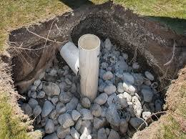
  - Leach pit for excrete disposal b) kitchen pit kitchen waste c) soak pit for disposal of waste water d) none
- Picture below is Dimitri Ivanosky, a Russian scientist , He is famous for what

  - Discovery of cholera b) discovery of virus c) invention of antibiotic d) none
8. Hardness is caused by

a)Calcium b) Magnesium c) both Calcium and Magnesium d) Multivalent metallic captions
9.0 SDG refers to the step by which organization
a) World bank b)UN c) USA d) WHO
10.0 Which of the following is a waterborne disease?
(a) Measles (b) Typhoid(c) Chickenpox(d) Flu
11)Water Chlorination is essential as it removes from water
a) Pathogenic organisms b)turbidity c) hardness d)none
- What does "WASH" stand for in the context of water, sanitation, and hygiene?
(a) Water and Sanitation for Health(b) Water, Air, and Sanitation for Humans(c) Water, Sanitation, and Hygiene(d) Water and Sanitation for Healthcare
- Which of the following is a consequence of poor sanitation?
(a) Reduced disease transmission (b) Improved public health(c) Increased spread of infectious diseases(d) Cleaner environments
Answer: (c) Increased spread of infectious diseases
- Which of the following is a benefit of hand washing with soap?
(a) Reduced risk of respiratory infections (b) Increased risk of foodborne illnesses(c) Improved oral hygiene(d) No impact on health
- Black colour of water indicate
  - good quality b) organic pollution c)bacterial presence d)Fluoride pollution
- Name the scientist whose belief in god influenced scientific perspectives of his research
  - Henry cavendish b) ioseph aspidin c) Louis paster d)Ronald ross
- Activated carbon which is highly useful in water treatment is obtained from
  - coconut shells b)waste wood c)red earth d) none
18) What is the purpose of the clarification or separation step at a wastewater treatment plant?
(a) To remove large solid objects (b) To separate scum and sludge from the liquid wastewater
(c) To treat wastewater with chlorine or ultraviolet light(d) To mix liquid wastewater with air to help bacteria break down solids
- Which of the following is a consequence of poor sanitation?
  - Reduced disease transmission(b) Improved public health(c) Increased spread of infectious diseases(d) Cleaner environments
- What is the primary purpose of a wastewater treatment plant?
(a) To make water potable(b) To remove pollutants from wastewater(c) To increase water levels
(d) To generate electricity

- Which of the following is a waterborne disease?
(a) Malaria(b) Tuberculosis(c) Cholera(d) Dengue
- What does BOD in water quality testing stand for?
- Basic Oxygen Demand(b) Biological Oxygen Demand(c) Bacterial Oxygen Demand(d) Biochemical . 23.
Acceptable standard as per IS 10500 2012 for sulphate in mg/litre
A)400 b)200 c)250 d) 450
24 . Permissible limit for hardness IS 10500 2012 in mg/litre
A)500 b) 600 c) 700 d) 650
25. Drinking water quality standard in India is proclaimed by ….
A) Central Pollution control board b) BIS c) NEERI Nagpur d) CWPR Oxygen Demand
26) White deposit on boiling in water indicates presence of
A) Iron b) hardness c) chloride d) nitrate
27). What is the important health significance of hardness?
A) on boiling white deposit is deposited b) hard water is good for heart diseases c) lather is formed with soap d)scaling in boilers
- When chlorine gas is added to water pH will …………..
a) increase b) decrease c) remains same d) none
- Which of the following is a method for conserving water?
(a) maintain water sources effectively (b) Rainwater harvesting(c) Using water-intensive appliances
(d) all of the above
- What is the main goal of the Swachh Bharat Mission?
(a) Promote tourism(b) Clean India(c) Improve infrastructure(d) Increase literacy
- Cholera is a dreadful disease. Which bacteria are responsible?
  - bacillus b) staphylococcus c) Vibrio d) none
- When should children wash their hands?
  - Before eating or preparing food b)After using the toilet or hands are visibly dirty
- After coughing, sneezing, or blowing their nosed) All of the above
- What is the role of a septic tank in sanitation?
(a) Purifies water for drinking(b) Treats wastewater from households(c) Stores rainwater
(d) Filters air
- What is the significance of chlorination in water treatment?

(a) Removes turbidity (b) Kills harmful bacteria(c) Adds minerals(d) Improves taste
- What is the effective method for disposal of plastic at domestic level
a) shredding b) Reuse c)landfill d) none
- Which of the following is true about bacteria?
a) Bacteria multiplies and grows faster in warm environments’) Bacteria needs air to survive c). Every type of bacteria can give people food poisoning.
- By freezing food you can kill bacteria.
- Deep well disposal of wastes not preferred due to
  - It reaches ground water easily b) It reaches surface water easily c) both d) none
- What element is added to water to prevent tooth decay?
a). Chlorine b). Fluoride). Sugar). None of these
- Which agency handles global health issues?
a) The World Health Organization, WHO b) the Food and Agriculture Organization, FAO
- the Centres for Disease Control d). the Food and Drug Administration, FDA
- Eutrophication in rivers is caused by
a) discharge of sediment in to the river b) excessive discharge of nutrients c) discharge of chlorides e) discharge of toxic substances
- World hand wash day is celebrated on
a) 15th october b) 15th September c) 15th November d) none
- Say true or false
Water logged areas are more prone for contamination due to ingression of surface contaminants
  - True b) False
- Which process is used to remove dirt and sand from wastewater?
a). Aeration b) Chlorination c) Sedimentation d ) Flocculation
- When acid is added to water pH
  - Increases b) decreases c) no change d) none
- Which of the following is not a waterborne disease? (a)Measles (b) Typhoid(c) Cholera(d) Hepatitis
- Jala jeevan mission is a programme of Government of India to promote
  - health and sanitation b)water quality and sanitation c) Provide safe water to the public by improving water supply systems in the country d) None
- What is the major advantage of water cycle

  - Natural treatment and distribution of water in the earth b)Conversion of water in to clean water c) Water conveyance through the earth d)None
- Which of this major illness is caused due to non-availability of sanitation facilities?
a. Fever b) Cold c) Diarrhoea d) none
- Which of the following is a benefit of hand washing with soap?
(a) Reduced risk of respiratory infections(b) Increased risk of foodborne illnesses(c) Improved oral hygiene (d) No impact on health
- What is meant by health sanitation linkage
  - Poor sanitation practices being a major contributor to disease and illness b) Health is directly linked to sanitation c)Santation measures are essential for all living beings
- All of the above
- Which ministry initiated the Swachch Bharat Mission?
A. Ministry of Environment and forest B. Ministry of Urban Development Housing
C. Ministry of Urban development D. Ministry of Drinking water and Sanitation 52 .Who is the inspiration behind the concept of SBM?
A. Mahatma Gandhi B. Jawaharlal Nehru C. Sardar Patel D. Morarji Desai
- Which award is given by the Indian Government to cities and villages for cleanliness?
A. Swach Puraskar B. Swachhta Puraskar C. Clean Region Award D. Nirmal Puraskar
- .Swachh Bharat Abhiyan was launched on the occasion the birth anniversary of a famous Indian leader. Who was it?
  - Mahatma Gandhi B. Netaji Subhash Chandra Bose C. Sardar Patel
- Who are responsible to keep neighbourhoods clean?
  - Municipal corporation B. Citizens and NGOs C. Municipal corporation, Citizens and NGOs
- Inspired by the Prime Minister of India, which country launched a similar event as the SBM on 3rd January 2015 in his own country?
A. Nepal B. Bhutan C. Srilanka D.China
- Why is hand washing necessary after defecation
  - For self-cleanliness & hygiene B. For home and family member’s cleanliness C. Both a & b 58 . Say true or false
Four SB Mission objectives are Elimination of open defecation, Eradication of manual scavenging and Capacity Building of ULB
59 .pH value can be increased by adding
- Carbonic acid b) sodium chloride c) lime d) none 60.oragnic pollution in water is assessed by the presence of

a) Biochemical oxygen demand b) chemical oxygen demand C) both D)None

